COMP1003: Algorithms, Data Structures and Mathematics
Practical – Hashing and Random Numbers

1) Random number generation

a) How can you generate floating point or double random numbers in the range from zero to one using randInt() ?

x = randInt( maxval ) / (maxval + 1.0) ;
will generate double or float values (depending on the type of x) . There will be maxval different ones only, equally spaces between zero and one.

b) In the definition of randInt: Where is the following line good for?
return( (int) __seed % value );

The random numbers can in principle go from 0 to MAX_VAL-1. In order to map them into the range 0 to value-1 one can use the % operation, which divides a number by value and returns the remainder. The (int) just casts the unsigned computations in randInt to an integer-type return value.

c) How many different random numbers does the generator produce?

RAND_MAX = 1771875

2) Hash table without collision handling

a) Run the code; follow the output; draw a picture that depicts the hash before the second insertion of the string "Peter".

null
null
Peter
Tom
null
Matthias

b) Analyse the insert() function. Draw a structogram.

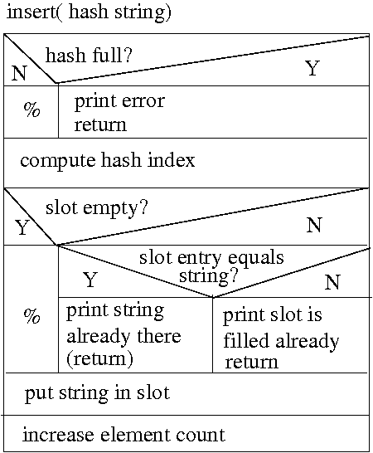

3) Hash table with linear shifting for collision handling -> nothing to do

